# Background and Related Work

## Introduction

My software will convert a picture into a cross stitch pattern. The user will be able to edit the pattern and customize it using different features of the program.

## Cross Stitch

### **History and Basics**

Cross stitching is a type of embroidery stitch art (Setiabudi et al, 2017). A picture is created using colourful thread and little cross shaped stitches on fabric. Usually two strands of cotton thread are used (Dyer, 1997). The stitching is done on fabric that has small holes: aida or evenweave. The colour range of the threads can be vast, the most widely used is made by DMC. There are only a few types of stitches since the final result should look uniform. The simple cross is used most of the time, however a half stitch, quarter stitch, three-quarter stitch and backstitching is also used occasionally (Atkinson & Roberts, 1999).

Figure - example of a cross stitch on aida

This art-form originated in Asia, and the oldest cross stitch dates back to 850 B.C. It became more popular in the Victorian era. Then, in 1980 cross stitch re-emerged again, and became how we know it today. It is one of the most popular type of needlework throughout the world (Leslie, 2007). It is a soothing and therapeutic hobby, and could help improve mental health (Hohmann, 2020).

A pattern is needed to make a counted cross stitch. A pattern consists of a grid with colourful squares (Biedl et al, 2005). The squares signal the position and colour of the stitch (Atkinson & Roberts, 1999). The size of a pattern is measured by the number of stitches across and down.

Figure - simple cross stitch pattern (Fitzgerald, 2017)

Figure – The way a pattern is converted to stitches (Biedl et al, 2005)

### Existing Software

There are a number of cross stitch pattern making software on the market with varied quality and features. The most popular and advanced one is WinStitch/MacStitch (2019).

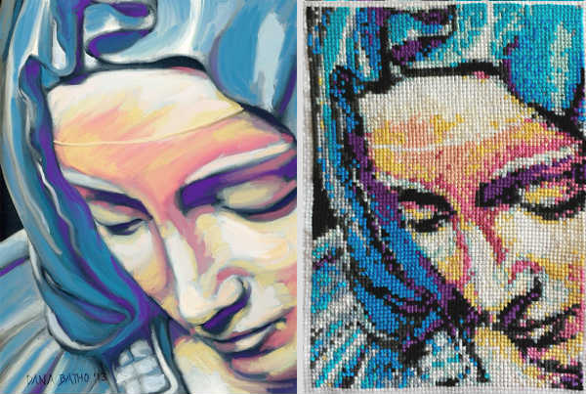

Figure 4- Painting and cross stitch (Batho, 2014)

## Frameworks

### WPF

### Windows Forms

### Comparison

## User Interface

### Another Subsection Title Rename Me

## Image manipulation

### Posterization

## Summary

References

Atkinson, K. R., & Roberts, J. C. (1999). Graphics and Visualization within Cross-Stitch. In Eurographics UK, Conference Proceedings, 1999 (pp. 129-141). Eurographics.

Biedl, T. C., Horton, J. D., & López-Ortiz, A. (2005). Cross-Stitching Using Little Thread. In *CCCG* (pp. 199-202).

Batho, D. (2014). Pieta [painting and cross stitch]. <https://peacockandfig.com/2015/02/from-a-painting-to-a-cross-stitch/>

Dyer, K. (1997). Counted Cross Stitch Tutorial. Retrieved November 18, 2020, from: <https://www.crosstitch.com/nfaq/nfaq1.html#>.

Fitzgerald, S. (2017). A beginner’s guide to cross stitch – Red Gate Stitchery. Retrieved November 18, 2020, from https://redgatestitchery.com/blogs/red-gate-stitchery/a-step-by-step-guide-to-cross-stitch

Hohmann, J. (2020) “We are all mad here”: A Content Analysis of Facebook Posts and Comments about the Impact of the Fibre Arts on Mental Health and Wellness.

Leslie, C. A. (2007). Needlework through history: An encyclopedia. Greenwood Publishing Group.

MacStitch and WinStitch. (2019). Retrieved November 18, 2020, from https://www.ursasoftware.com/macstitch/index.html

Setiabudi, D., Isa, S. M., & Iswanto, B. H. (2017). Digital color classification for colorful cross stitch threads using RGB+Euclidean Distance and LAB+CIE94. Proceedings of 2016 International Conference on Information and Communication Technology and Systems, ICTS 2016, 150–156. <https://doi.org/10.1109/ICTS.2016.7910290>